**Tasty (Medium)**

**Our analysts were able to gain console access to an unknown airgapped (no internet) server and need help determining some information.**

**What Linux distribution is the server running?**

1. Type *cat /etc/os-release* in terminal.
2. Answer: CentOS

**What package group was installed?**

**What package manager plugin was installed?**

1. Type *yum history list* in the terminal.

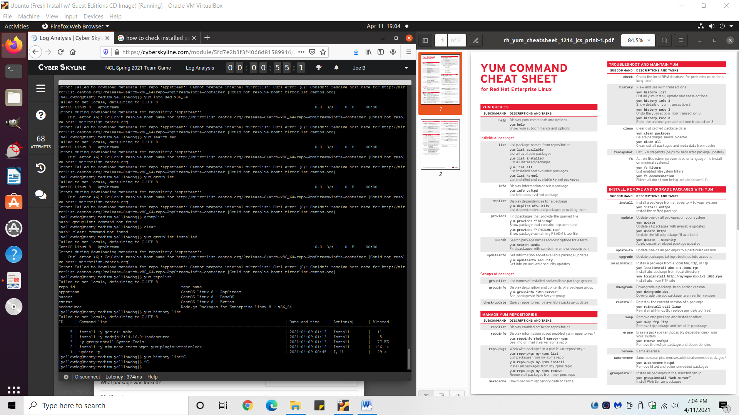

1. Answer: *Forgot to record both of the exact answers, but it’s one of the package groups in lines 1-5 in the image above.

**How many packages are installed on the system?**

1. Type *yum list -n installed* in the terminal.
2. Copy all of the output.
3. Paste the output into a line counter web tool.
   1. <https://www.google.com/url?sa=t&rct=j&q=&esrc=s&source=web&cd=&cad=rja&uact=8&ved=2ahUKEwi7gqSqsPfvAhWKZM0KHZ_MAXoQFjAAegQIBBAD&url=https%3A%2F%2Fminiwebtool.com%2Fline-counter%2F&usg=AOvVaw2AUVssj37I_X6HyyMkRv5f>
4. Answer: 425

*Unanswered questions:

**What package was locked?**

**What repository was added?**

**What is the URL for said repository?**

**What is the name of the source package for the installed version of sed?**